CARD 6
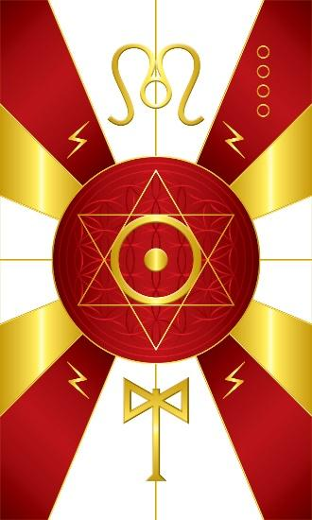
Card 6 represents the energy of Heru/Shango. The colors along the outside of the circle are Red, White, & Gold. In the middle is the astrological glyph of the Sun. Above is the glyph for the constellation of Leo, but stylized to create symmetry. The Leo symbol, or glyph, is designed to depict the Lion and its mane and two halves of the heart. In Kemet, Heru is also associated with the Ab/Heart. Below is the double axe of Shango and as the God of Thunder and lightning, lightning symbols are positioned in the quadrants. The flower of life pattern in the middle is the structural basis of the 6 pointed star as the geometrical symbol. The sacred number for Heru/Shango is 6.

Comments by Baba Awodele

